**Data Flow Diagram:**

Project Design Phase-II

Data Flow Diagram & User Stories

|  |  |
| --- | --- |
| Date | 29 October 2022 |
| Team ID | PNT2022TMID25832 |
| Project Name | Project - Smart Solutions for Railways |
| Maximum Marks | 4 Marks |

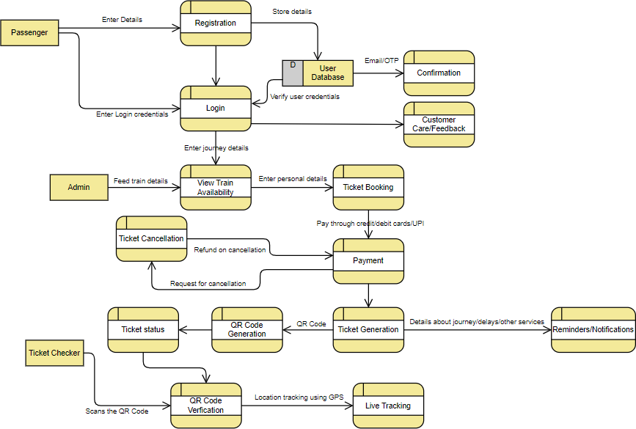

**User Stories**

Use the below template to list all the user stories for the product.

|  |  |  |  |  |  |  |
| --- | --- | --- | --- | --- | --- | --- |
| **User Type** | **Functional Requirement (Epic)** | **User**  **Story Number** | **User Story / Task** | **Acceptance criteria** | **Priority** | **Release** |
| Customer  (Mobile user, Web user) | Registration | USN-1 | As a user, I can register through the form by filling in my details. | I can register and create my account /dashboard | High | Sprint-1 |
|  |  | USN-2 | As a user, I can register through phone  numbers, gmail, facebook or other social sites. | I can register & create my  dashboard with Facebook Login or other social sites | High | Sprint-2 |
|  | Confirmation | USN-3 | As a user, I will receive confirmation  through email or OTP once registration is successful. | I can receive confirmation  email & click confirm | High | Sprint-1 |
|  | Authentication/Login | USN-4 | As a user, I can login via login ID and  password or through OTP received on registered phone number. | I can login and access my  account/dashboard | High | Sprint-1 |
|  | Display train details | USN-5 | As a user, I can enter the start and | I can view the train | High | Sprint-1 |
|  |  | destination to get the list of trains available | details(name & number), |  |  |
|  |  | connecting the above. | corresponding routes it |  |  |
|  |  |  | passes through based on |  |  |
|  |  |  | the start and destination |  |  |
|  |  |  | entered. |  |  |
|  | Booking | USN-6 | As a user, I can provide the basic details  such as name, age, gender etc. | I can view,modify or  confirm the details entered. | High | Sprint-1 |
|  |  | USN-7 | As a user, I can choose the class,  seat/berth. If a preferred seat/berth isn’t available I can be allotted based on the availability. | I can view, modify or  confirm the seats/class/berth selected | High | Sprint-1 |
|  | Payment | USN-8 | As a user, I can choose to pay through | I can view the payment | High | Sprint-1 |
|  |  | credit card/debit card/UPI. | options available and |  |  |
|  |  |  | select my desirable choice |  |  |
|  |  |  | to proceed with the |  |  |
|  |  |  | payment. |  |  |
|  |  | USN-9 | As a user, I will be redirected to the | I can pay through the | High | Sprint-1 |
|  | selected payment gateway and upon | payment portal and |  |  |
|  | successful completion of payment I’ll be | confirm the booking.If any |  |  |
|  | redirected to the booking website. | changes need to be done I |  |  |
|  |  | can move back to the |  |  |
|  |  | initial payment page. |  |  |

|  |  |  |  |  |  |  |
| --- | --- | --- | --- | --- | --- | --- |
| **User Type** | **Functional Requirement (Epic)** | **User**  **Story Number** | **User Story / Task** | **Acceptance criteria** | **Priority** | **Release** |
|  | Ticket generation | USN-10 | As a user, I can download the generated e-ticket for my journey along with the QR  code which is used for authentication during my journey. | I can show the generated QR code so that  authentication can be done quickly. | High | Sprint-1 |
|  | Ticket status | USN-11 | As a user, I can see the status of my ticket whether it’s confirmed/waiting/RAC. | I can constantly get the information and arrange alternate transport if the  ticket isn’t confirmed. | High | Sprint-1 |
|  | Reminders/Notification | USN-12 | As a user, I get reminders about my journey  a day before my actual journey. | I can make sure that I  don’t miss the journey  because of the constant notifications. | Medium | Sprint-2 |
|  |  | USN-13 | As a user, I can track the train using GPS  and can get information such as ETA, current stop and delays. | I can track the train and  get to know about the delays and plan accordingly. | Medium | Sprint-2 |
|  | Ticket cancellation | USN-14 | As a user, I can cancel my ticket if there’s  any change of plan. | I can cancel the ticket and  get a refund based on how close the date is to the commencement of the  journey. | High | Sprint-1 |
|  | Raise queries | USN-15 | As a user, I can raise queries through the query box or via mail. | I can view my previous queries. | Low | Sprint-2 |
| Customer Care Executive | Answer the queries | USN-16 | As a user, I will answer the queries/doubts raised by the customers. | I can view the queries and mark it once resolved. | Medium | Sprint-2 |
| Administrator | Feed details | USN-17 | As a user, I will feed information about the trains, delays and add extra seats if a new compartment is added. | I can view and ensure the correctness of the information fed. | High | Sprint-1 |